WEEK 3 Entity Framework Core 8.0 Hands On

**Lab 1: Understanding ORM with a Retail Inventory System:**

**Step-1: ORM (Object-Relational Mapping)** is a programming technique that allows developers to interact with a database using objects from their programming language instead of raw SQL.

**How ORM Works in C#:**

* A C# class maps to a database table.
* Properties of the class map to columns.
* An object instance maps to a row in the table.

**Benefits of ORM:**

* **Productivity**: Reduces the need to write boilerplate SQL.
* **Maintainability**: Code-first development is easier to update and manage.
* **Abstraction**: Use LINQ queries instead of SQL.

**Step**-2: EF Core VS EF Framework

| **Feature** | **EF Core** | **EF Framework (EF6)** |
| --- | --- | --- |
| Platform | Cross-platform (.NET Core) | Windows-only (.NET Framework) |
| Performance | Lightweight and faster | More mature but heavier |
| Features | LINQ, async/await, compiled models | Lacks some modern features |
| Use Case | New cloud-based or cross-platform apps | Legacy enterprise apps |

**Step-3:** EF Core 8.0 includes new features like:

* **JSON Column Mapping** – Support for storing/querying JSON in SQL Server.
* **Compiled Models** – Faster app startup and improved performance.
* **Interceptors** – Hook into database operations for custom logic.
* **Bulk Operations** – Improved support for batch inserts/updates/deletes.

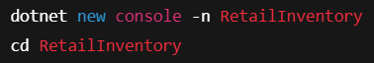**Step**-4:

**Step-5:**

**Lab 2: Setting Up the Database Context for a Retail Store:**

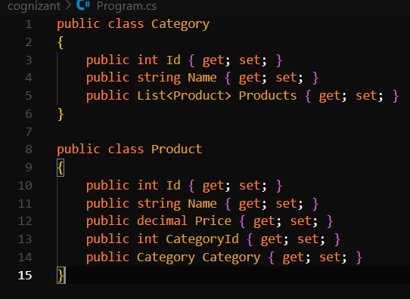**Step-1:**

**Step-2:** 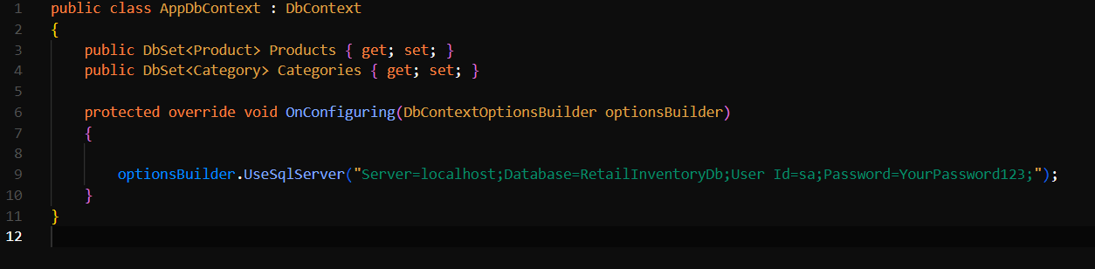

**Step-3:**

In appsettings.json :

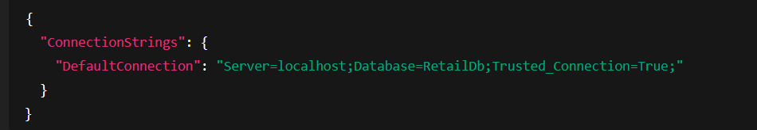

In Program.cs:



**Lab 3: Using EF Core CLI to Create and Apply Migrations:**

**Step-1:**



**Step-2:**



**Step-3:**

**Lab 4: Inserting Initial Data into the Database:**

**Step-1:**

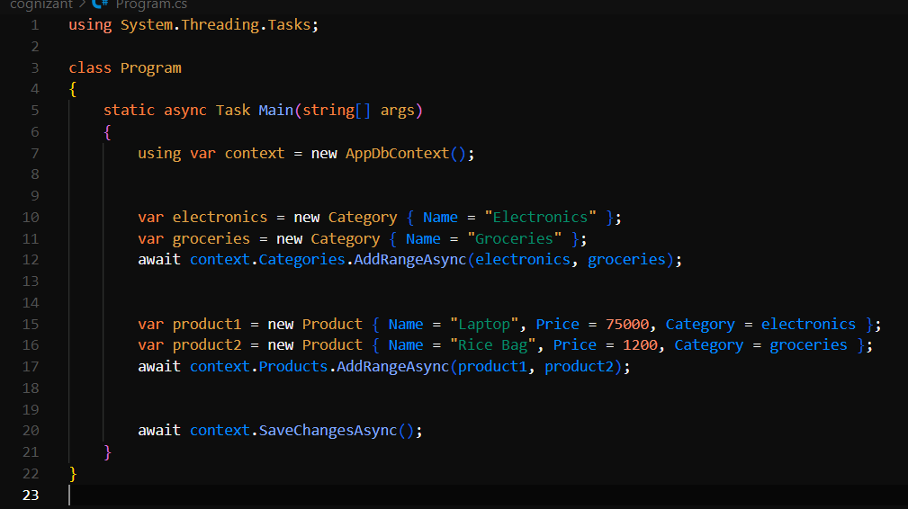

**Step-2:**



**Step-3:**

Products table

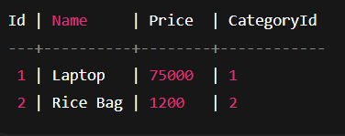

Categories table

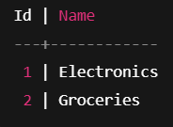

**Lab 5: Retrieving Data from the Database:**

**Step-1:**

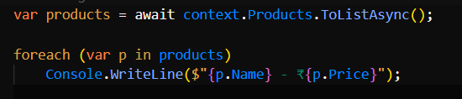

**Step-2:**

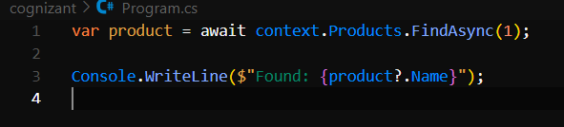

**Step-3:**

